 |  |  |  |  |  |  |  |  |  |  |  |  | PCS 100518
EUROPEAN UNION (BIOCIDAL PRODUCTS) REGULATIONS
BIOCIDAL PRODUCT NOTIFICATION
 | The Department of Agriculture, Food and the Marine as the Competent Authority for Biocides in Ireland, pursuant to Regulations 9 and 10 of the European Union (Biocidal Products) Regulations 2013 (S.I. 427 of 2013), hereby declare that the Notification Holder:
 | DUGGAN VET. SUPPLIES LTD.
 | HOLY CROSS, THURLES, CO TIPPERARY
 | has notified the biocidal product:
 | Alvodex 70% alcohol hand gel
 | to the Competent Authority for Biocides in order to make available on the market in Ireland.
 | It is the responsibility of the Notification Holder to ensure that: the product label(s) and safety data sheets are in compliance with the relevant Regulations; changes to the product must be notified to the Competent Authority for Biocides in Ireland prior to the change to the product; information on the product must be supplied to the National Poisons Information Centre of Ireland (http://www.poisons.ie/manufacturers.asp) before product is made available on the market.
 | Product Summary
 | Product Name: |  |  | Alvodex 70% alcohol hand gel |  |  |  |  | PCS No: | PCS 100518
 | Formulation Type: |  |  | Other liquids to be applied undiluted [AL] |  |  |  |  | MG/PT: | MG01 | / | PT1
 | Category of Use(s): |  |  | Non Professional, Professional
Active Substance(s) | CAS No. | (% w/w)
Ethanol | 64-17-5 | 70.00000

 | On behalf of the Competent Authority for Biocides in Ireland:
 | 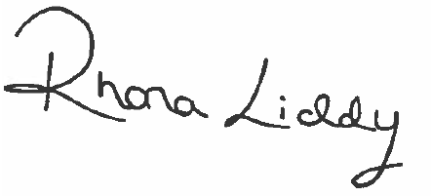
 | Date of issue: |  |  |  |  | 23/09/2020
 | Official Stamp:
 | 